Week 15 Lab: Checks, Subqueries, Window Functions

LIS 464 Applied Database Design

Information School, University of Wisconsin-Madison

Deliverable: Each student submit their own document, but you are welcome to work in groups/help one another. If you cannot get your functions to work, submit screenshots showing your effort.

## Problem Set 1: Make a Check

Step 1: On Akira 2: Create a new simple table Animals with three attributes AnimalID, AnimalName, AnimalWeight. For weight, use an attribute type that will capture 5 total digits and two decimal points.

Step 2: Create a constraint, similar to the one in lecture, that produces an error if one enters a weight over 100 pounds. Insert a screenshot showing the successful creation of your check.

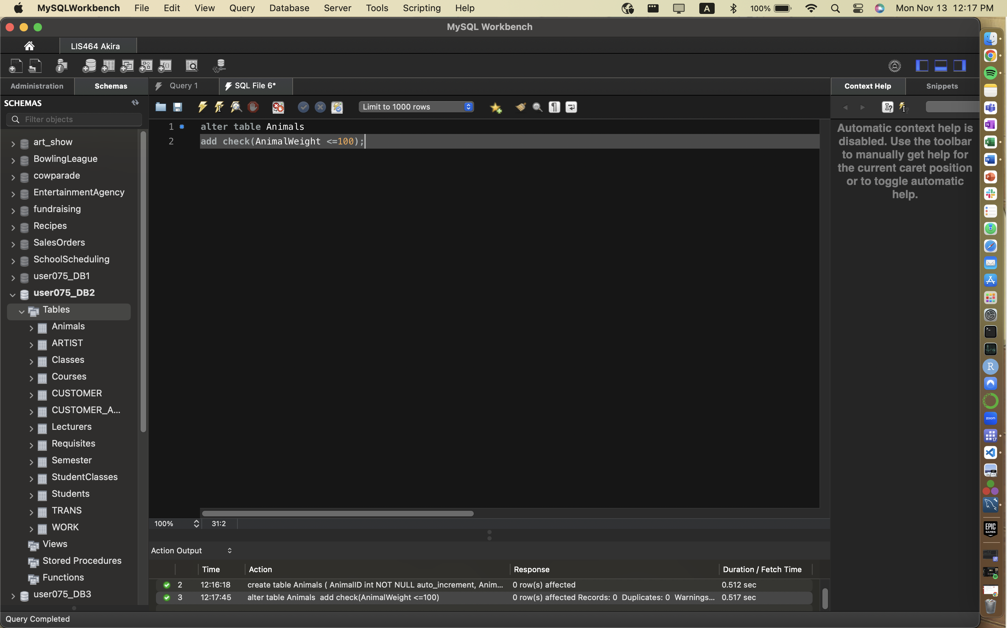

Example from lecture:

ALTER TABLE test.persons

ADD CHECK (Age>=18);

Step 3. Add data that will trigger/violate the constraint

Step 4: Add a screenshot showing your error message you receive when trying to enter the data in Step 3.

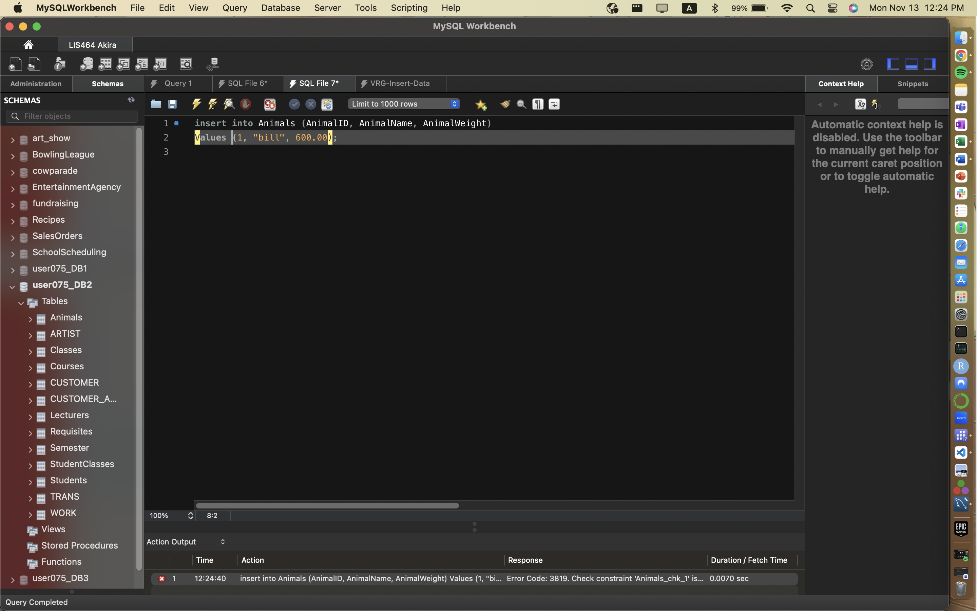

## Problem Set 2: Subqueries (Use Recipes Database ERD at end)

### **2.1 Scalar Subquery (2 points) evaluate data against a single numerical value.**

Use the Recipes Database at end of document. Use tables Recipe_Classes and Recipes. Post a screenshot showing both your query, the output window result showing number of rows and part of the results set.

Query: Use the subquery syntax (no joins) to produce a list of the titles of all dessert recipes.

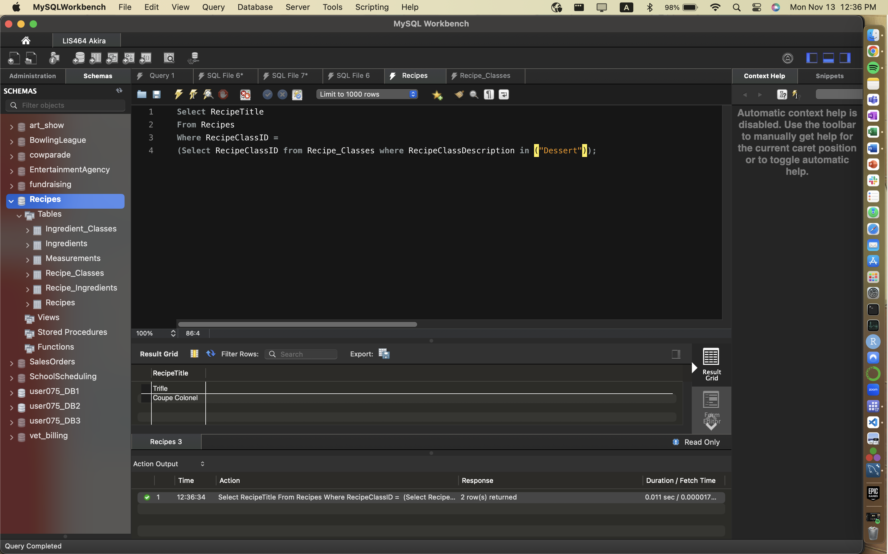

***2.2 (2points) Multi-row list***

Use the Recipes Database (see end of document). Use tables Recipe_Ingredients and Recipes. Post a screenshot showing both your query, the output window result showing number of rows and part of the results set.

Query: Use the subquery syntax (no joins) to produce a list of the ingredientid and measureamountid for recipes whose titles begin with the letter M.

## Part 3: Window Function

***3.1 (2points) Open window problem***

(open window problem) Use Classes table. Using the window function syntax, write a query to compare the time length of each class to the average class length. Include ClassID, duration of the class, and the average duration of all classes.

***3.2 (2points) defined/closed window problem***

Use students table. Using the defined/closed window function syntax, write a query to list the number of students in each state. Include StudState, and a count of Student ID. Get rid of repeating rows.

